**I. Using AutoTrace**

*Table of Contents*

1. Locating AutoTrace Program

2. Adding Images

3. Beginning Tracing

4. Setting Grid

5. Creating Trace

6. Tracing Guidelines

7. Checking Output

8. Exiting

*AutoTrace is a program used to take Ultrasound tongue images and trace the tongue. Data points are put along a fan-shaped grid over the image of the tongue in order to track the movement of the tongue during speech.*

1. Locating AutoTrace Program
   1. Use Spotlight to find “*AutoTrace.py*”
   2. Open program (should be within “*LabTools*”; both versions work)
      1. AutoTrace program window and Terminal should open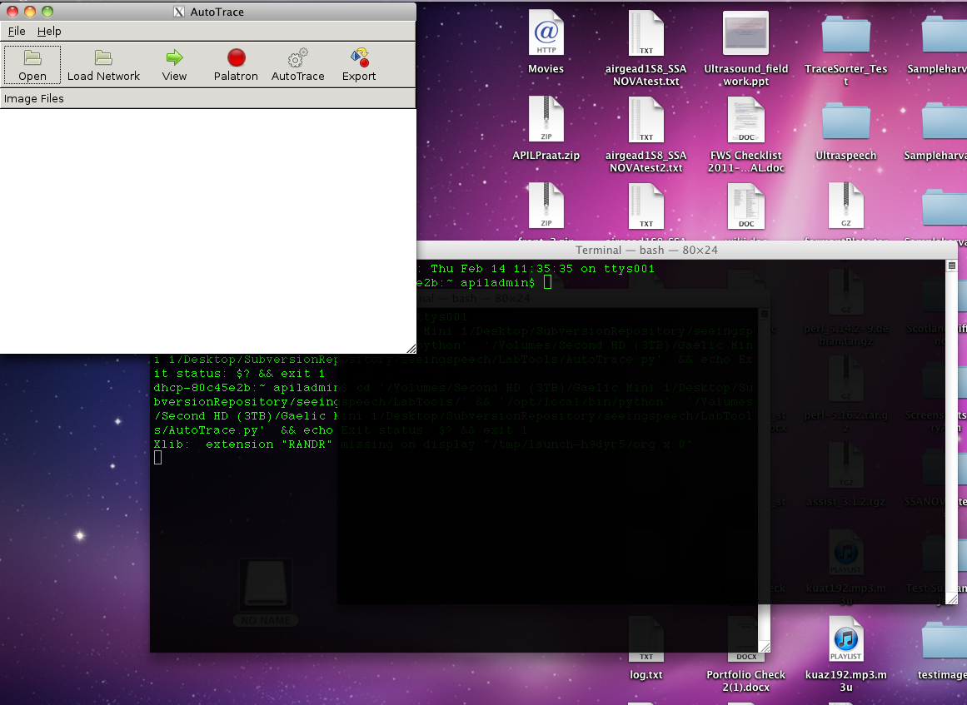
2. Adding Images to Autotrace
   1. To import images, click “*open*” button found on top left of program
   2. To import multiple images: select first image, hold shift, and select last desired image
   3. Once images are selected, click “*open*”
3. Beginning Tracing
   1. Select one image and click “*view*” found on top center of program
   2. A new window will open
   3. When prompted, enter *tracer information* (first and last initials)
4. Setting the Grid
   1. If yellow grid lines are not aligned with edges of image, click “*set grid*” (at top of program) to remove the lines

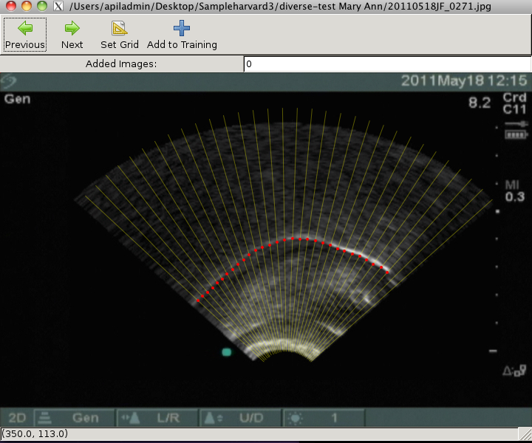

*An incorrect grid (gridlines are not aligned with edges of image)*

* + 1. Draw new grid lines from bottom left edge to top left edge and bottom right edge to top right edge (if drawn from right to left, the grid will be inverted and you will need to back out by closing out of the window and returning to “adding images” section)
    2. The grid can only be set once while the image is open (if a mistake is made, you must back out to redraw the grid)

1. Creating the Trace
   1. Image should appear as black with white line(s) splitting mouth into upper palate and tongue
   2. Hold *left mouse button* and trace line of tongue
      1. Place dots starting from either left or right
         1. *Important*: dots should be just below the white line, on the border between the white and black of the tongue image
      2. *Tip*: it can help to draw *rough arch*, then *fine tune* dot placements (only one dot will appear per gridline)
   3. If needed, hold right mouse button and move over any existing dots to erase
   4. When finished with image, click “next” at top of program; work will automatically be saved
   5. Old traces will be saved in separate folder
   6. Once work is saved, it can accessed in “recent traces” folder (folder is automatically named with tracer information of all tracers who have placed traces in folder using AutoTrace)
2. Tracing Guidelines
   1. Dots should be *just below* white border
   2. If the tongue border is unclear, *do not* place dots
   3. If “double tongue” occurs, choose *lower* line (upper is usually palate)
   4. If no distinct lines can be made out, the image may be “bad” and be *untraceable*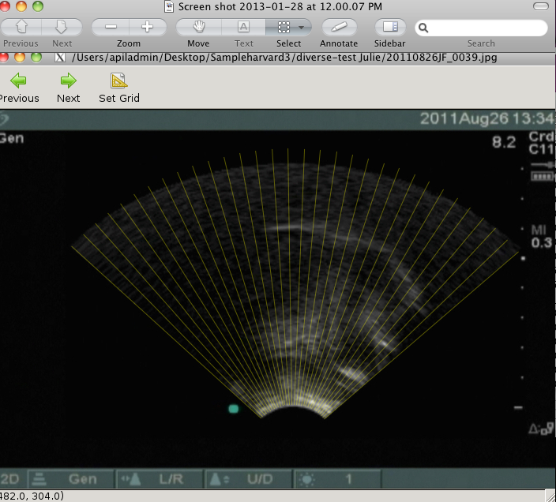

*Untraceable image*

e. Some images may be distorted; if this occurs, *do not* attempt to trace

1. Checking Output
   1. A complete tongue tracing should now have a correct grid and accurately traced tongue image

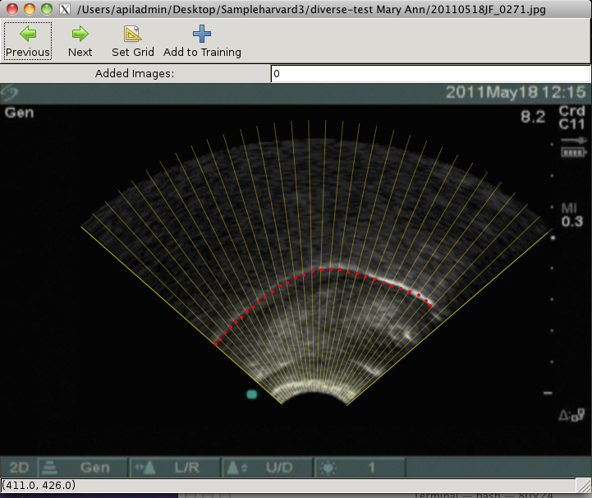

*Desired result*

1. Exiting
   1. Once finished with work, exit program, all work will be saved and you will be returned to initial AutoTrace screen